**PROJECT REPORT**

**MEASURING THE PULSE OF PROSPERITY: AN INDEX OF ECONOMIC FREEDOM ANALYSIS**

Project submitted to the thiruvalluvar university by the team members

1. **M Afisha (Reg no:34620U25018)**
2. **Kokila G (Reg no:34620U25017)**
3. **Mahalakshmi R (Reg no:34620U25019)**
4. **Malathi S (Reg no:34620U25020)**

**M.M.E.S WOMENS ARTS AND SCIENCECOLLEGE,MELVISHARAM.**

**TABLE OF CONTENT**

|  |  |  |
| --- | --- | --- |
| **S.NO** | **TOPIC** | **PAGE NO** |
| 1 | Introduction | 3 |
| 2 | Problem definition and design thinking | 7 |
| 3 | Result | 9 |
| 4 | Advantages and disadvantages | 26 |
| 5 | Application | 27 |
| 6 | Conclusion | 27 |
| 7 | Future scope | 28 |
| 8 | Appendix | 29 |

**PROJECT REPORT**

**1.INTRODUCTION**

* 1. **OVERVIEW**

**PROJECT DESCRIPTION**

Economic freedom is the fundamental right of every human to control his or her own labor and property. In an economically free society, individuals are free to work, produce, consume, and invest in any way they please. In economically free societies, governments allow labor, capital, and goods to move freely, and refrain from coercion or constraint of liberty beyond the extent necessary to protect and maintain liberty itself.

For much of human history, most individuals have lacked economic freedom and opportunity, condemning them to poverty and deprivation.

Today, we live in the most prosperous time in human history. Poverty, sicknesses, and ignorance are receding throughout the world, due in large part to the advance of economic freedom. In 2022, the principles of economic freedom that have fueled this monumental progress are once again measured in the Index of Economic Freedom, an annual guide published by The Heritage Foundation, Washington's No. 1 think tank. We measure economic freedom based on 12

quantitative and qualitative factors, grouped into four broad categories, or pillars, of economic freedom:

**1. Rule of Law**

1. Property Rights: The extent of a country’s ability to legally protect the property rights of an individual.
2. Judicial effectiveness: The extent of the efficiency and fairness of the judiciary when it comes to dealing with property laws
3. Government Integrity: It examines how strong the government is and how prevalent practices such as bribery, extortion, nepotism, cronyism, patronage, embezzlement, and graft.

**2. Government size**

1. Tax Burden: Analyzes marginal tax rates on personal and corporate income and the overall taxation level – including direct tax and indirect tax – as a percentage of the [GDP](https://byjus.com/free-ias-prep/gdp-of-india-upsc-notes/).
2. Government spending: Analyzes the quantity of government expenditures and its resulting burden. It consists of consumption by the state and all transfer payments related to various entitlement programs.
3. Fiscal health: It examines how well a nation manages its budgets by quantifying growing debt and deficit.

**3. Regulatory Efficiency**

1. Business Freedom: Analyses the cost, time and freedom to open, operate and close a business, taking into consideration factors like electricity.
2. Labour Freedom: Quantifies the intrusiveness of labor rights such as minimum wage, laws inhibiting layoffs, severance requirements, and measurable regulatory restraints on hiring and hours worked, plus the labor force participation rate.
3. Monetary freedom: Examines how stable are prices and how much microeconomy intervenes.

**4. Market openness**

1. Trade freedom: Quantifies the extent to which tariff and nontariff barriers affect imports and exports of goods and services into and out of the country.
2. Investment freedom: Analyses how free or constrained is the flow of investment capital of individuals and firms.
3. Financial Freedom: Indicates banking efficiency as well as how independent the government is from the financial sector.

**1.2 PURPOSE**

An index of economic freedom measures and ranks countries according to relevant standards judged by the creators of the index. Not all economists will agree on the relevant criteria, of course.

Indices of economic freedom consider free-market economies at the high-end of the spectrum for analysis. There is a firm correlation between both the earnings a country's citizens enjoy and the index of economic freedom ranking of such country. Investors can use the index of economic freedom as a faster way to observe the changes in economies.

Using the Economic Freedom Index, users can discover innovative ways to use the index in science, public policy, enterprise, and advocacy. The index is an excellent analytical tool for evaluating 186 economies worldwide, and each country page is a platform for examining the political and economic trends of a nation in depth.

**2 PROBLEM DEFINITION AND DESIGNING THINKING**

**2.1 EMPATHY MAP**

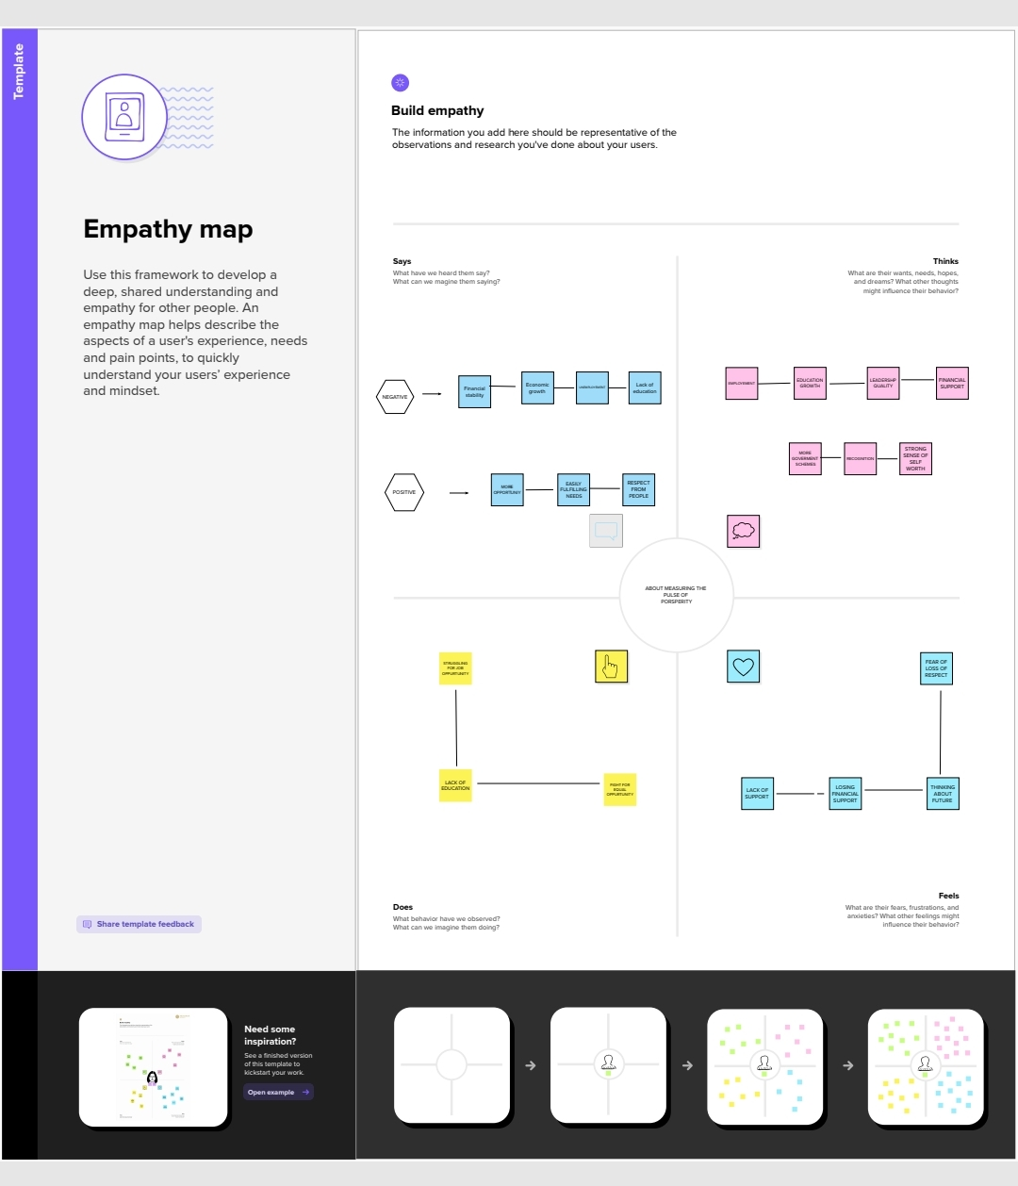

* 1. **IDEATION AND BRAINSTORMING**

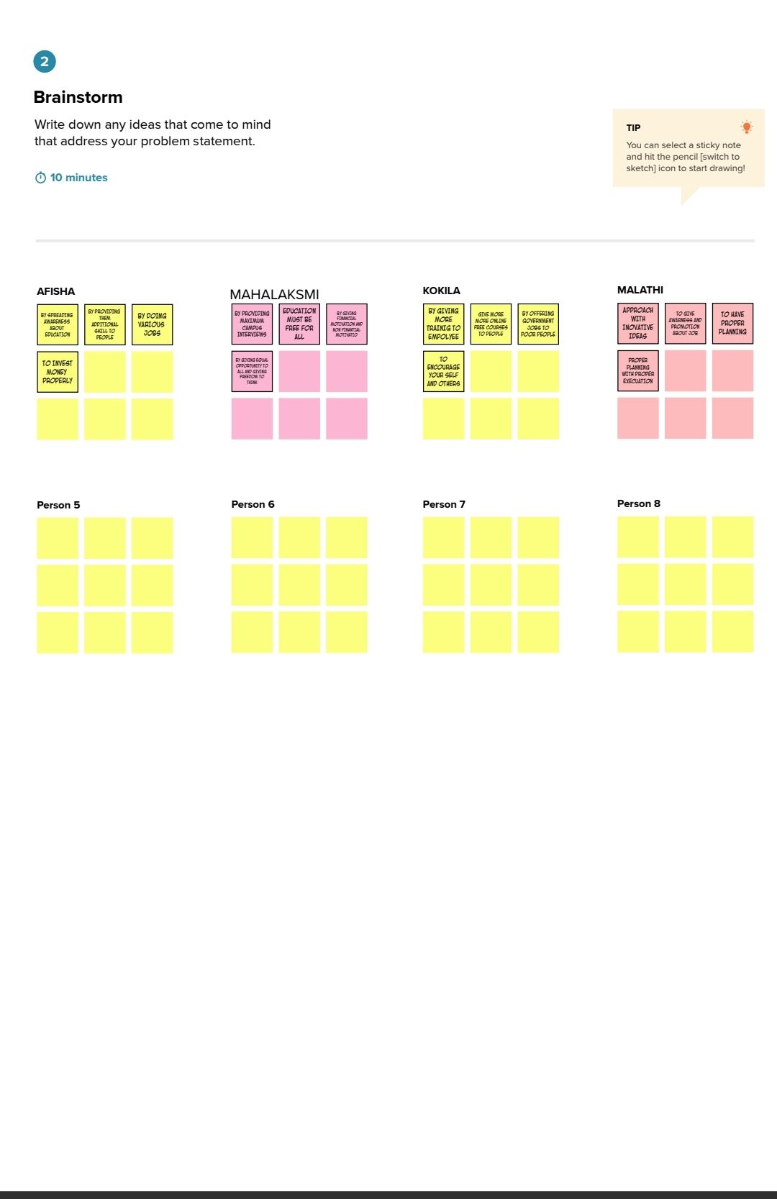

**3.RESULT**

SHEET 1-2022 ECONOMIC FREEDOM SCORE

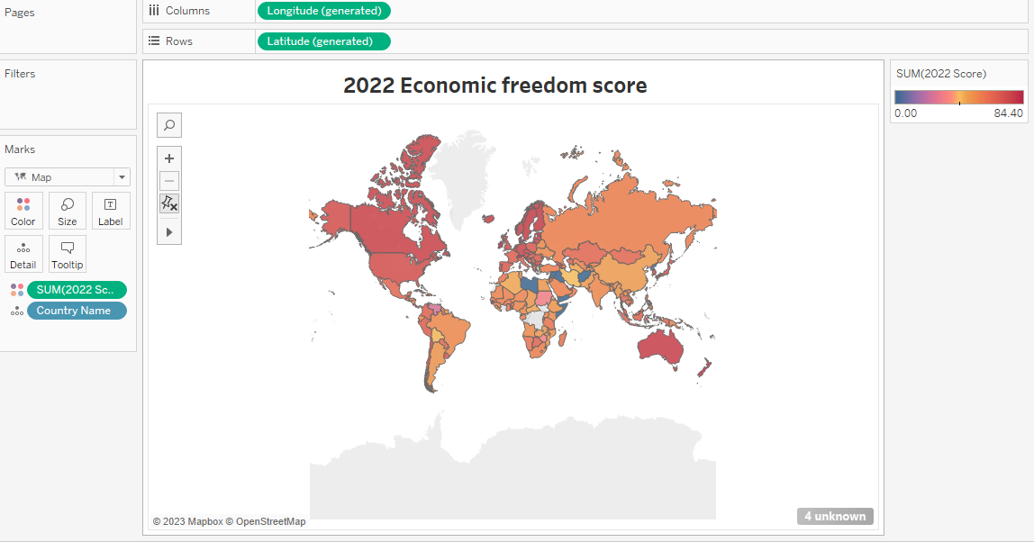

SHEET 2- TOP 40 RANKING COUNTRIES

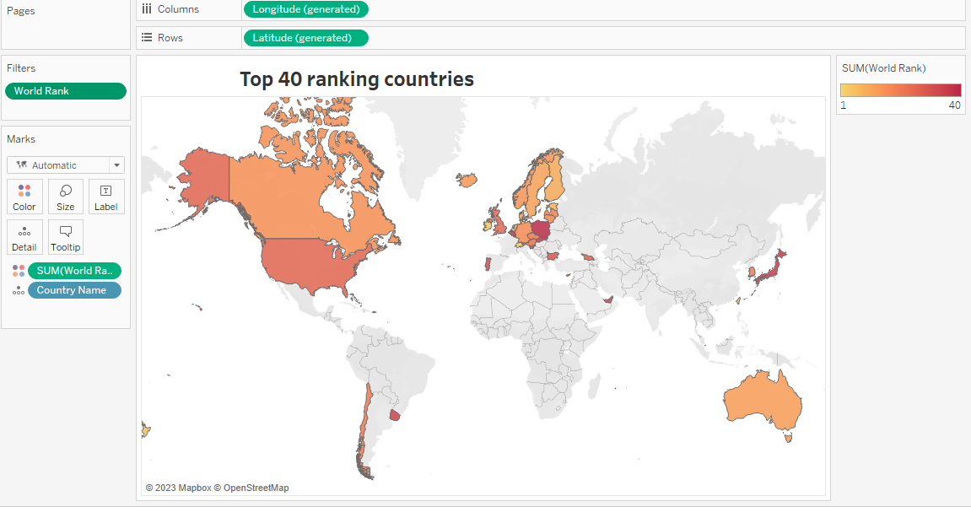

SHEETS 3- BOTTOM RANKING COUNTRIES

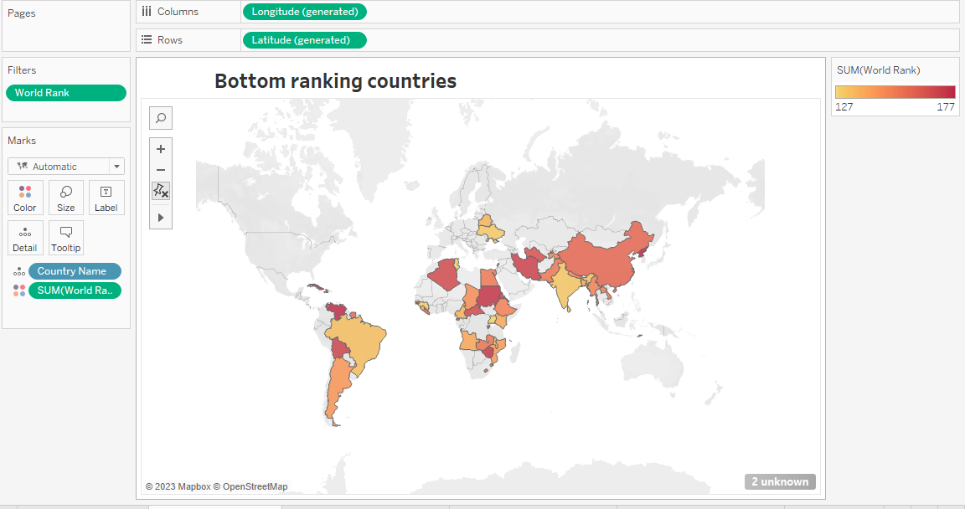

SHEET 4- INDEX SCORE BASED ON UNEMPLOYEMENTF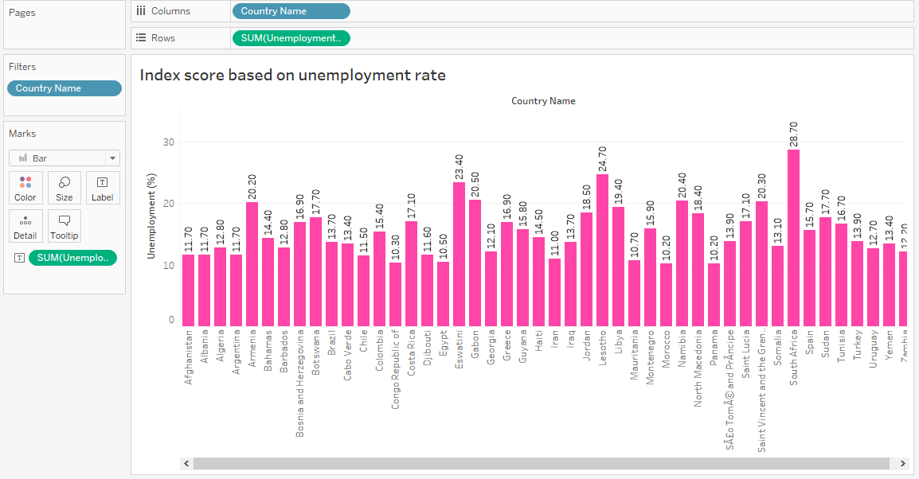

SHEET 5 INDEX BASED ON FINANCIAL FREEDOM

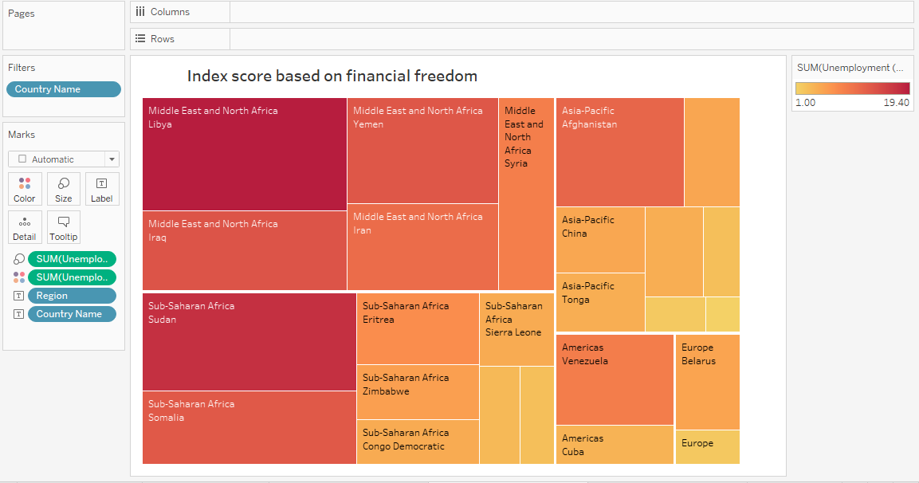

SHEET 6 INDEX BASED ON POPULATION

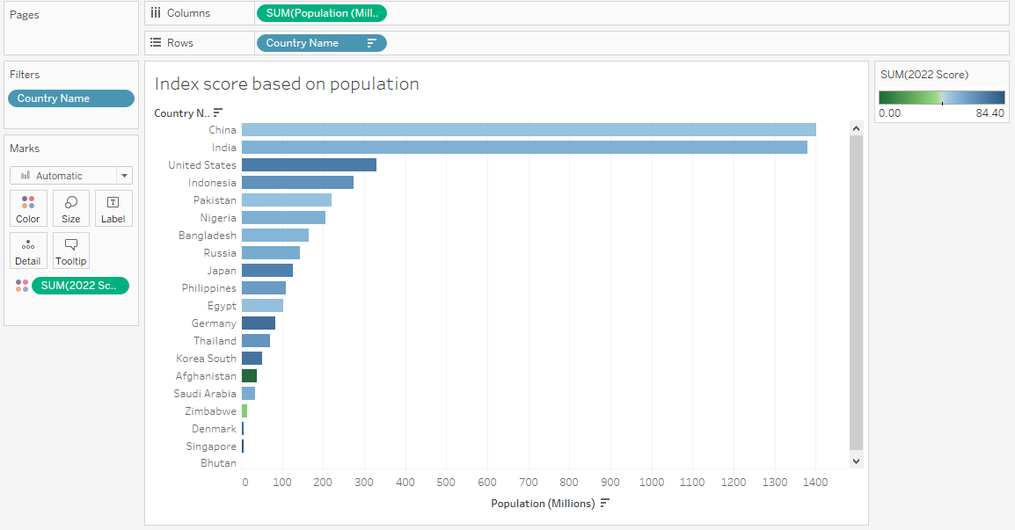SHEET 7 – INDEX BASED ON 5 YEAR GDP GROWTH RATE

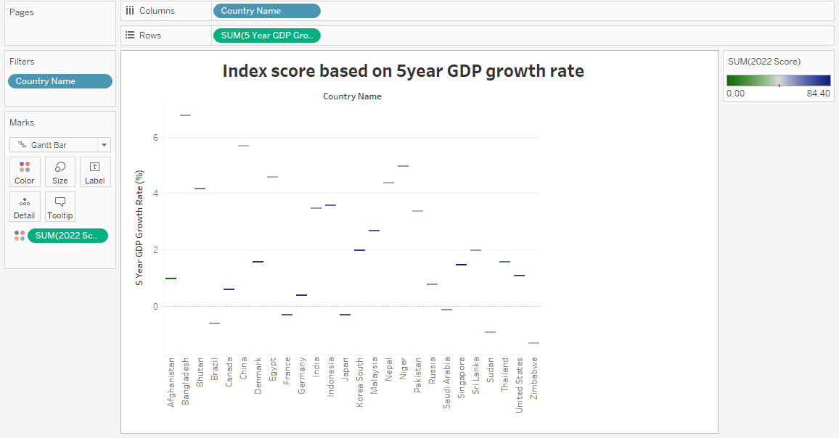

SHEET 8 – INFLATION RATE IN DIFFERENT COUNTRIES

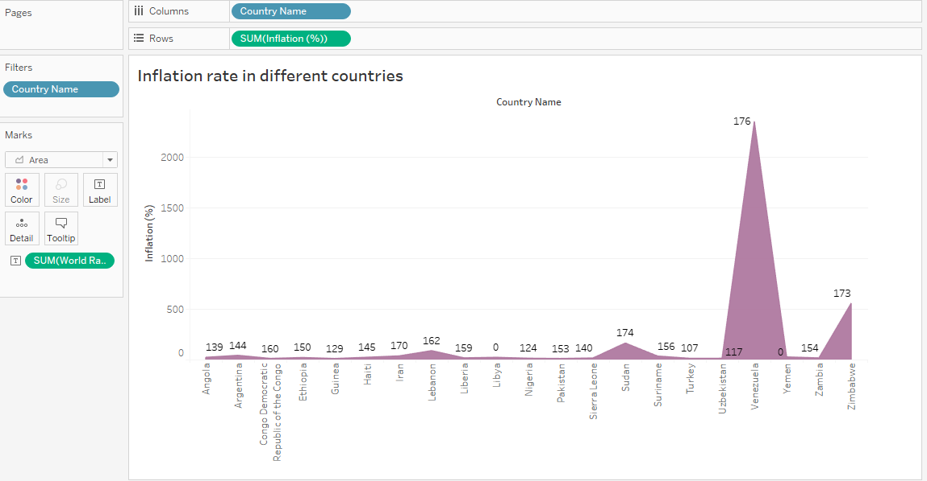

SHEET 9- CORRELATION BETWEEN INFLATION AND UNEMPLOYMENT

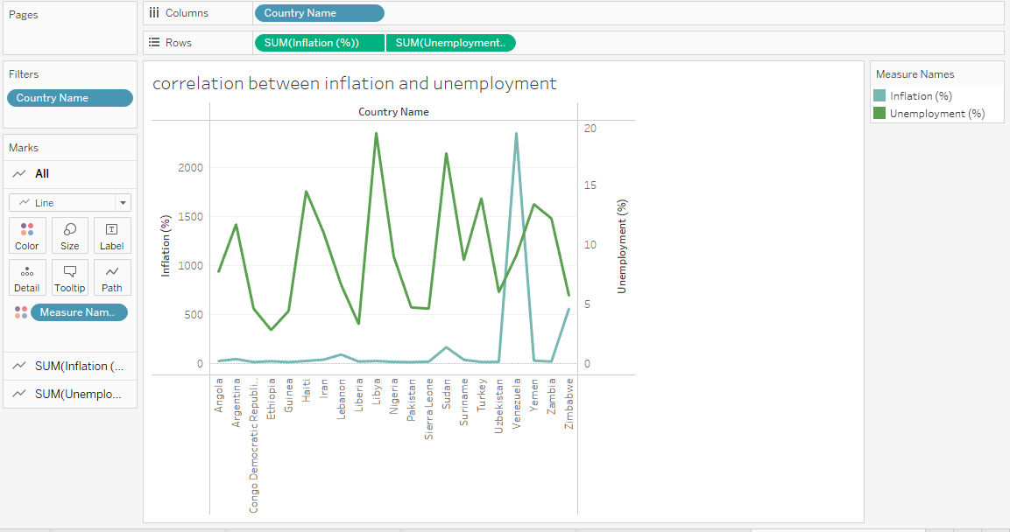

SHEET 10 - CORRELATION BETWEEN GDP(PPP) AND MONETARY FREEDOM

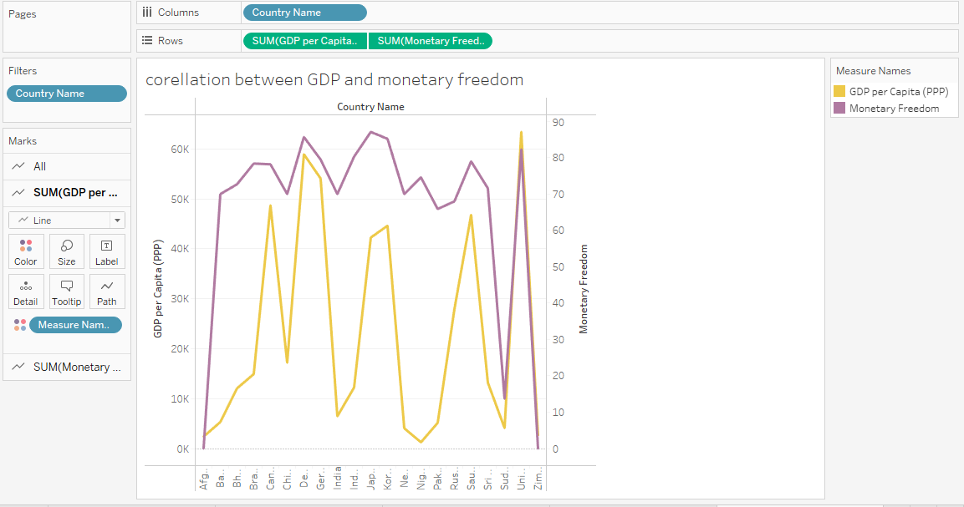

SHEET 11- TOP 40 COUNTRIES BY GDP GROWTH RATE

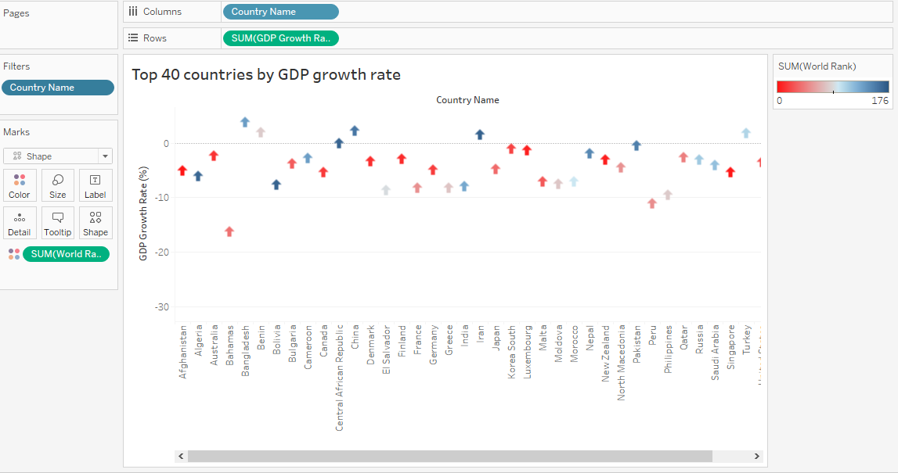

DASH BOARDS

DASHBOARD 1-

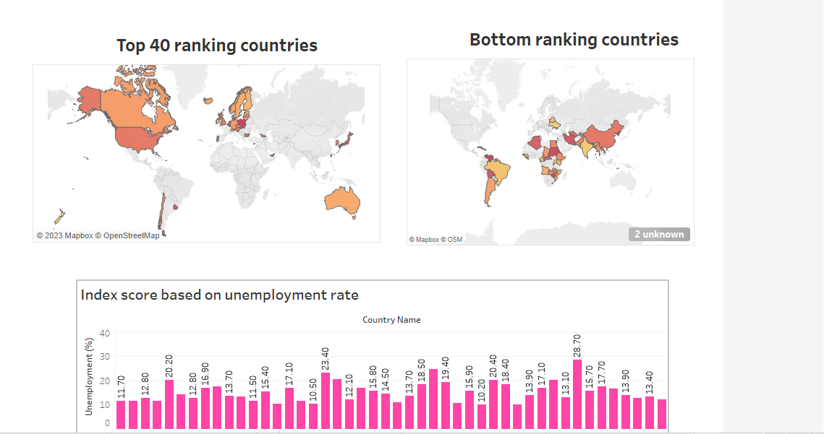

DASHBOARD 2 –

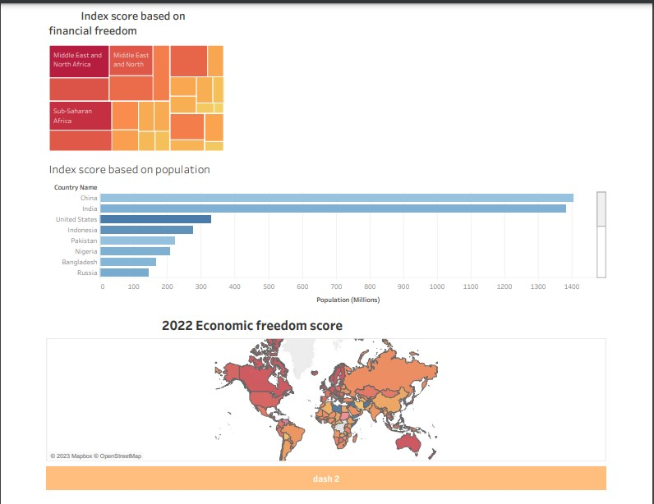

DASH BOARD 3

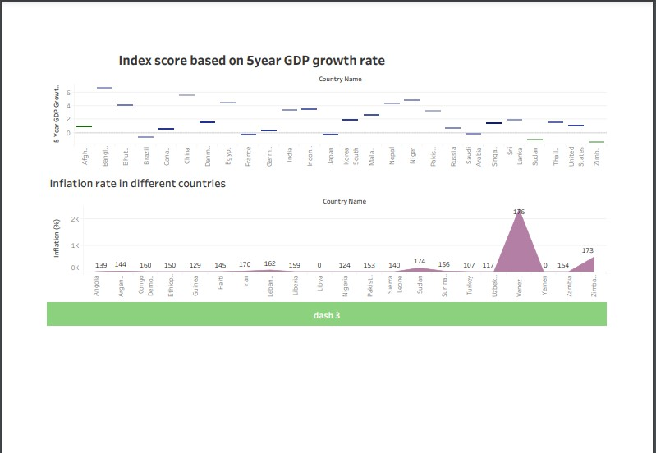

DASHBOARD 4

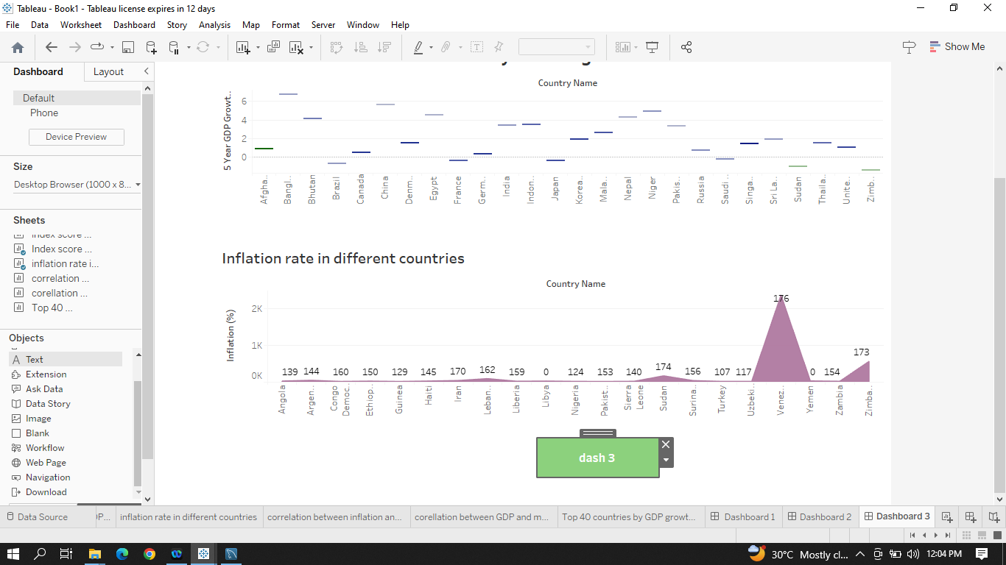

DASH BOARD 5

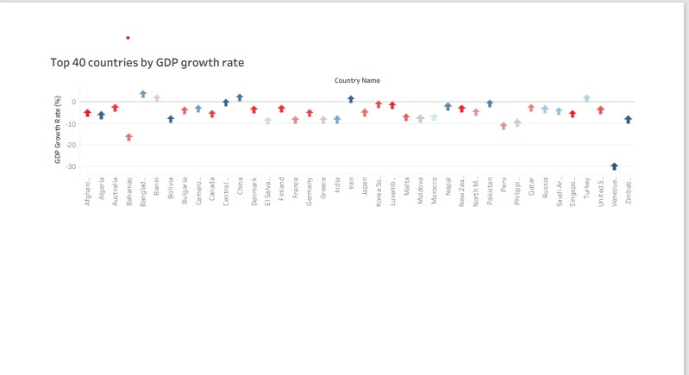

STORIES

STORY 1

2022 ECONOMIC SCORE

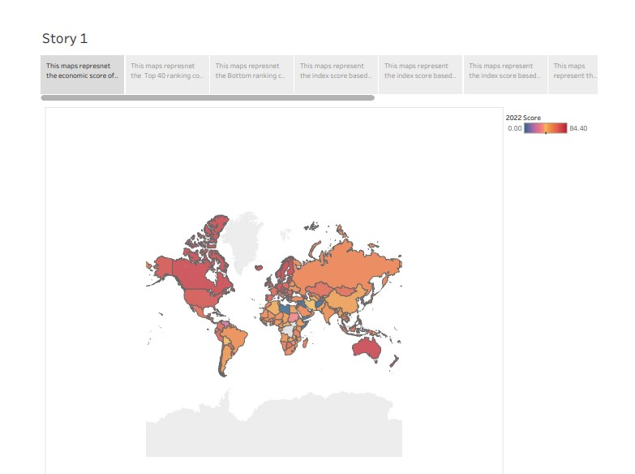

TOP 40 RANKING COUNTRIES

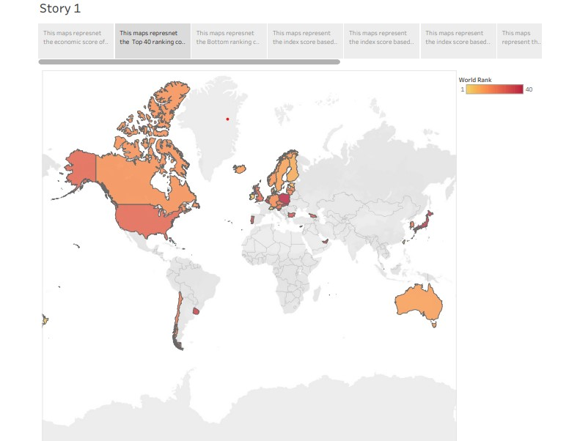

BOTTOM RANKING COUNTRIES

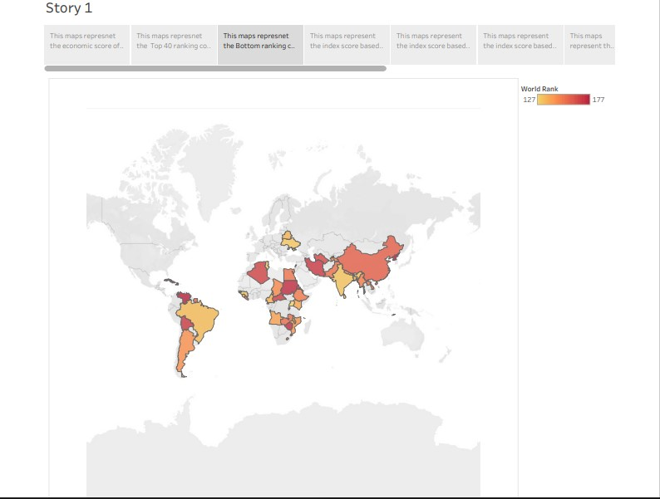

INDEX SCORE BASED ON UNEMPLOYMENT

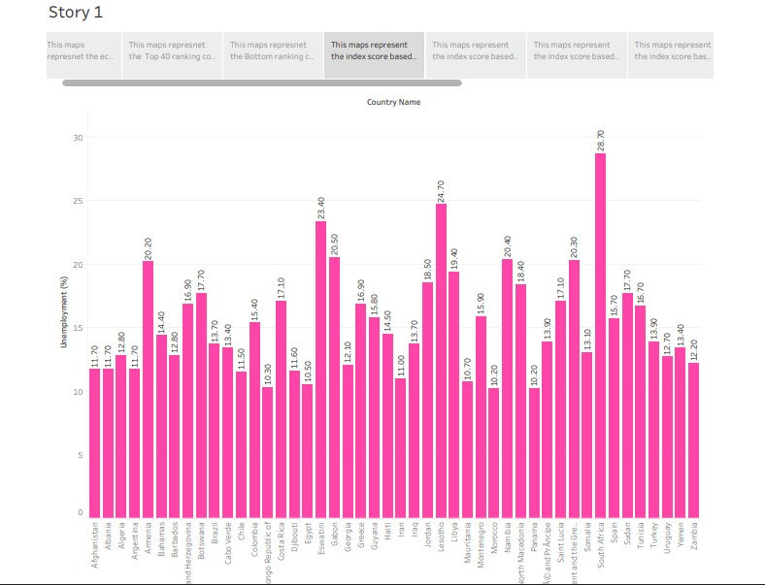

INDEX BASED ON FINANCIAL FREEDOM

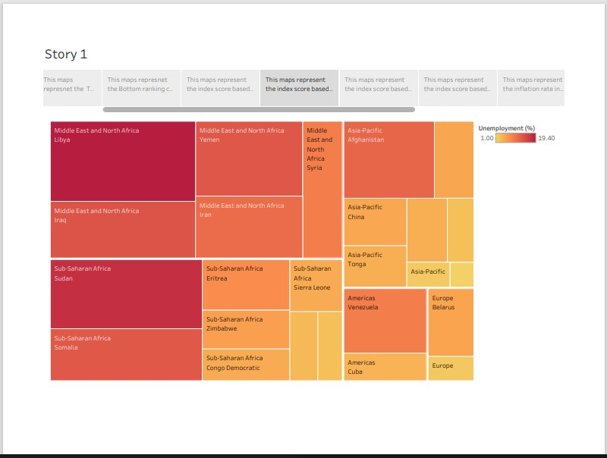

INDEX BASED ON POPULATION

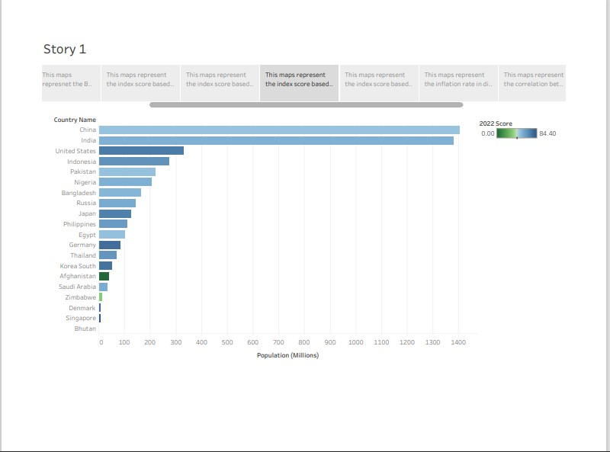

INDEX BASED ON 5 YEAR GDP GROWTH RATE

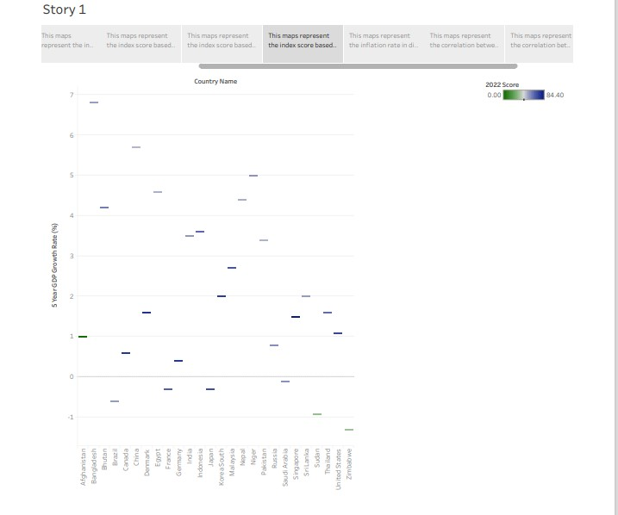

INFLATION RATE IN DIFFERENT COUNTRIES

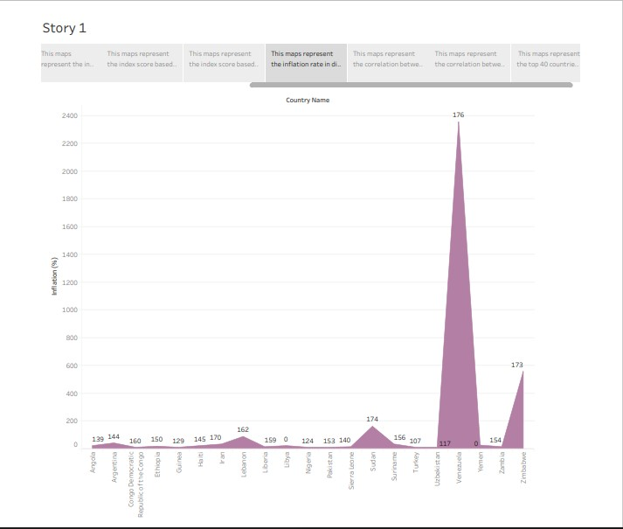

CORRELATION BETWEEN INFLATION AND UNEMPLOYMENT

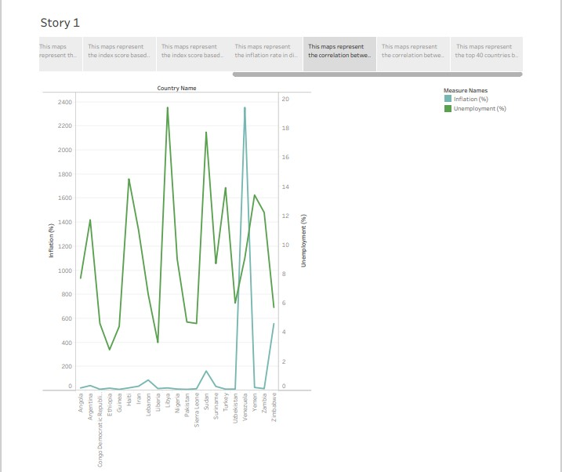

CORRELATION BETWEEN GDP(PPP)AND MONETRAY FREEDOM

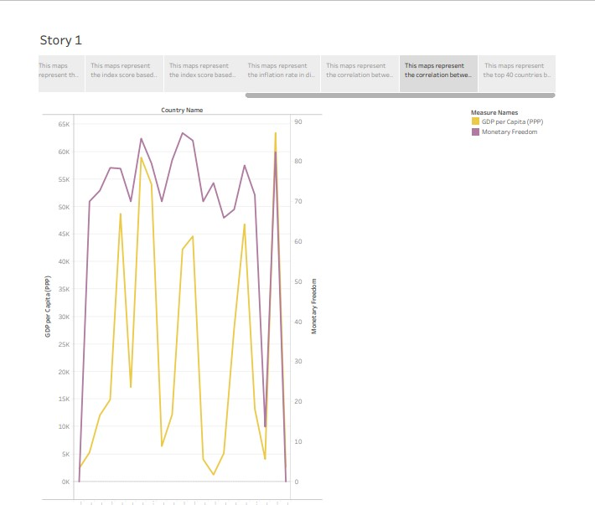

TOP 40 COUNTRIES BY GDP GROWTH RATE

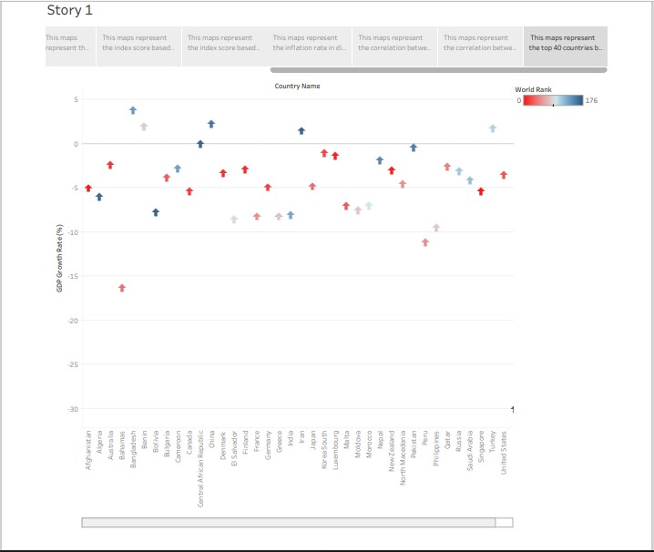

**4. ADVANTAGEDS AND DISADVATAGES OF PROPOSED SOLUTION**

Economic freedom is the fundamental right of every human to control his or her own labor and property. In an economically free society, individuals are free to work, produce, consume, and invest in any way they please. In economically free societies, governments allow labor, capital, and goods to move freely, and refrain from coercion or constraint of liberty beyond the extent necessary to protect and maintain liberty itself.

Economic freedom brings greater prosperity. The Index of Economic Freedom documents the positive relationship between economic freedom and a variety of positive social and economic goals. The ideals of economic freedom are strongly associated with healthier societies, cleaner environments, greater per capita wealth, human development, democracy, and poverty elimination. For further information, see especially:

**5.APPLICATIONS OF AN INDEX OF ECONOMY FREEDOM ANALYSIS**

* An index of economic freedom is a composite measure of the quality of political-economic institutions across different jurisdictions.
* Scores and ranks in an index are based on criteria that the creators of the index judge as being relevant, which vary from one index to another.
* These indexes are motivated by the observation that economies that are more free-market based tend to experience greater levels of investment, more rapid growth, and higher average incomes.
* Investors can use the index of economic freedom as a quick way to monitor the changes in economies where they are interested in exposure.
* The Heritage Foundation publishes the most widely-used economic freedom index. However, several institutions publish their own indices.

**6. CONCLUSION**

We worked with MY SQL, tableau and connected MY SQL To tableau and in VS CODE and worked in 11 visualization that is

1. 2022 economic freedom score
2. Top 40 ranking countries
3. Bottom ranking countries
4. Index score based on unemployment
5. Index score based on financial problem
6. Index score based on population
7. Index score based on 5 year GDP growth rate(%)
8. Inflation rate in different countries
9. Correlation between inflation and unemployment
10. Correlation between GDP(PPP) and unemployment
11. Top 40 countries by GDP growth rate

And created 11 sheets,5 dashboards and 11 story which we have shown in results.

**7. FUTURE SCOPE**

For well over a hundred years, the economic world has been engaged in a great intellectual debate. On one side of this debate have been those philosophers and economists who advocate an economic system based on private property and free markets—or what one might call economic freedom. The key ingredients of economic freedom are personal choice, voluntary exchange, freedom to compete in markets, and protection of person and property. Institutions and policies are consistent with economic freedom when they allow voluntary exchange and protect individuals and their property.

Governments can promote economic freedom by providing a legal structure and a law-enforcement system that protect the property rights of owners and enforce contracts in an evenhanded manner. However, economic freedom also requires governments to refrain from taking people’s property and from interfering with personal choice, voluntary exchange, and the freedom to enter and compete in labor and product markets. When governments substitute taxes, government expenditures, and regulations for personal choice, voluntary exchange, and market coordination, they reduce economic freedom. Restrictions that limit entry into occupations and business activities also reduce economic freedom.

**8. APPENDIX**

<div class='tableauPlaceholder' id='viz1681492480972' style='position: relative'><noscript><a href='#'><img alt=' Dashboard 1 ' src='https:&#47;&#47;public.tableau.com&#47;static&#47;images&#47;ne&#47;new_dashboard_16813690759790&#47;Dashboard1&#47;1_rss.png' style='border: none' /></a></noscript><object class='tableauViz' style='display:none;'><param name='host_url' value='https%3A%2F%2Fpublic.tableau.com%2F' /> <param name='embed_code_version' value='3' /> <param name='site_root' value='' /><param name='name' value='new_dashboard_16813690759790&#47;Dashboard1' /><param name='tabs' value='no' /><param name='toolbar' value='yes' /><param name='static_image' value='https:&#47;&#47;public.tableau.com&#47;static&#47;images&#47;ne&#47;new_dashboard_16813690759790&#47;Dashboard1&#47;1.png' /> <param name='animate_transition' value='yes' /><param name='display_static_image' value='yes' /><param name='display_spinner' value='yes' /><param name='display_overlay' value='yes' /><param name='display_count' value='yes' /><param name='language' value='en-US' /></object></div> <script type='text/javascript'> var divElement = document.getElementById('viz1681492480972'); var vizElement = divElement.getElementsByTagName('object')[0]; if ( divElement.offsetWidth > 800 ) { vizElement.style.width='1000px';vizElement.style.height='827px';} else if ( divElement.offsetWidth > 500 ) { vizElement.style.width='1000px';vizElement.style.height='827px';} else { vizElement.style.width='100%';vizElement.style.height='977px';} var scriptElement = document.createElement('script'); scriptElement.src = 'https://public.tableau.com/javascripts/api/viz_v1.js'; vizElement.parentNode.insertBefore(scriptElement, vizElement); </script>